A Project Report On

**Tourism Management System**

Post-Graduation

MCA / M. Sc. IT / Integrated M. Sc. IT

Silver Oak College of Computer Application

Submitted to



Department of Masters

Silver Oak College of Computer Application

Silver Oak University

Submitted By: Under the Guidance of

Name1 : Nayan Pravinbhai Sarvaliya FacultyName

Enrollment Number1: 2304070100134 Asst. Prof.

Name2 : Arpit Divykant Bhai Dave Department of Masters

Enrollment Number2 : 2304070100022 College of Computer Application

Name3 : Omkumar Jitendrabhai Patel

Enrollment Number3 : 2304070100108



**Silver Oak College of Computer Application**

**Department of Computer Application**

**Masters of Computer Application**

**Certificate**

Date:

This is to certify that the project report submitted along with the project entitled **[YOUT PROJECT NAME]** has been carried out by **("NAYAN PRAVINBHAI SARVALIYA " (2304070100134)**) under guidance of Asst. Prof. Mitul Ghediya in fulfillment of the MCA (Sem 3), Degree of Master of Computer Application at Silver Oak College of Computer Application, Silver Oak University, Ahmedabad during the academic year 2024-25.

Mr. Mitul Ghediya Ms. Risha Tiwari

Project Guide HOD



**Silver Oak College of Computer Application**

**Department of Computer Application**

**Masters of Computer Application**

**Certificate**

Date:

This is to certify that the project report submitted along with the project entitled **[YOUT PROJECT NAME]** has been carried out by **("ARPIT DAVE DIVYKANTBHAI" (2304070100022)**) under guidance of Asst. Prof. Mitul Ghediya in fulfillment of the MCA (Sem 3), Degree of Master of Computer Application at Silver Oak College of Computer Application, Silver Oak University, Ahmedabad during the academic year 2024-25.

Mr. Mitul Ghediya Ms. Risha Tiwari

Project Guide HOD



**Silver Oak College of Computer Application**

**Department of Computer Application**

**Masters of Computer Application**

**Certificate**

Date:

This is to certify that the project report submitted along with the project entitled **[YOUT PROJECT NAME]** has been carried out by **("OMKUMAR JITENDRABHAI PATEL" (2304070100108)**) under guidance of Asst. Prof. Mitul Ghediya in fulfillment of the MCA (Sem 3), Degree of Master of Computer Application at Silver Oak College of Computer Application, Silver Oak University, Ahmedabad during the academic year 2024-25.

Mr. Mitul Ghediya Ms. Risha Tiwari

Project Guide HOD



**Acknowledgement**

We Express Our Heart Gratitude to a number of people Who Extended Their Full Support and Cooperation in Developing This Project. Firstly, We Would Like to Take This Opportunity to Thank "Silver Oak University" For Giving Us This Opportunity and A Platform for Discovering and Developing Our potential, The King of Experience That We Have Received While Making This Project Report Is So Immense That Narrating That in Few Word Is Difficult.

After Putting in Such a Hard-work We Have Realized That Takes to Work in Company and Do A Project. Our Project name is "**[TOURISM MANAGEMENT SYSTEM]**" And Colleagues have been Great Source of Help without Them We Were Unable to Do This Project. There for our Project. As If Small Drop of Water of Sea. We Have Learnt Many Things from Being a Part of Concept Family.

After That Our Heartiest Thanks to Our Guide as Well as Respected Mentor "Mr. Mitul Ghediya" For Entrusting Upon Us the Responsibility and Acting as Ray of Light in Darkness. We Find Our Self-Short of Words to Describe Our Feeling for the Role she played Of Friend, A Philosopher and Guide, Whenever We Were in Need.

* **Front Page**
* **Certificate**
* **Acknowledgement**
* **Preface**
* **Index**

|  |  |  |  |  |  |  |
| --- | --- | --- | --- | --- | --- | --- |
| **Index** | | | | | | |
| **Sr. No** | **Title** | | | | | **Page Number** |
| **1** | **PROJECT TITLE** | | | | | **7** |
| **2** | **PROBLEM DEFINITION** | | | | | **7** |
| **3** | **NEED OF PROJECT** | | | | | **8** |
| **3.1** | **CURRENT SYSTEM AND ITS DRAWBACK** | | | | **8** |
| **3.2** | **PROPOSED SYSTEM AND ITS FEATURE** | | | | **9** |
| **4** | **REQUIREMENT** | | | | | **10** |
| **4.1** | **SOFTWARE(Client side and Server side)** | | | | **10** |
| **4.2** | **HARDWARE (Client side and Server side)** | | | | **10** |
| **5** | **TIME DURATION** | | | | | **10** |
| **6** | **TECHNOLOGY USED** | | | | | **10** |
| **7** | **FUNCTIONAL AND NON- FUNCTIONAL DEPENDENCY** | | | | | **11** |
| **8** | **Design** | | | | | **12** |
| **8.1** | | | **System Flow Diagram** | | **12** |
| **8.2** | | | **UML Diagrams OR Data Flow Diagram** | | **13** |
| **8.2.1** | **USE CASE OR Context Level / 0 level** | **13** |
| **8.2.2** | **ACTIVITY OR First level** | **14** |
| **8.2.3** | **SEQUENCE OR Second level** | **14** |
| **8.2.4** | **CLASS** | **15** |
| **8.3** | | **ER Diagram** | | | **15** |
| **8.4** | | **Data Dictionary** | | | **16** |
| **8.5** | | **SCREENSHOTS OF MODULE** | | | **18** |
| **9** | **APPLICATION** | | | | | **24** |
| **10** | **EXPECTED OUTCOMES** | | | | | **24** |
| **11** | **FUTURE SCOPE** | | | | | **25** |
| **12** | **REFERENCES** | | | | | **25** |

1. **PROJECT TITLE :**

**Tourisim Management System**

Tourism has turned out to be an economic booster contributing to the economic development of many countries over the last few decades.

  People see holidays as a necessity, and not as luxury in the present scenario. Tourism calls for coordination and cooperation between travel agents, tour operators, and tourists.

Tourism has a few major elements − destinations, attractions, sites, accommodation, and all ancillary services. The need for a robust and dynamic tour management application has been around since the advent of the tourism

1. **PROBLEM DEFINITION :**

**Time and resource management:**Manually tracking bookings, managing inventory, and interacting with customers can be time-consuming and prone to errors.

**Lack of customer relationship:**There may be a lack of relationship between travel agencies and customers.

**Matching travel services to customer priorities:**It may be difficult to match travel services to customer priorities.

**Providing accurate travel information:** It may be difficult to provide accurate travel information.

**3. NEED OF PROJECT :**

**Automation:**A TMS can automate the processes and activities of a travel agency, making it easier to manage tourists, bookings, and places.

**Information access:**A TMS can make it easier to access information about travel to a particular destination.

**Efficiency:**A TMS can increase the efficiency of information management by replacing manual methods.

**Accuracy:** A TMS can provide accurate information to tourists.

**Flexibility:** A TMS can make traveling activities easier and more flexible.

**Document management:**A TMS can address issues such as document management and lost records.

**Coordination:**A TMS can streamline and enhance the coordination of tourist activities and services.

**3.1: CURRENT SYSTEM AND ITS DRAWBACK:**

The main problem projected is that pupils’ particulars are reported manually in distinct records, which is a laborious job. Handling and updating these records manually increase the chances of mistakes. It takes a lot of time and needs many employees to accomplish the task. It even lacks security and inability to produce various types of reports.

No User Friendly

Manual Operation

No Security Features

HIGHER education is characterized by “the tension between the offered quality and the drive to provide affordable higher education to more and more people

**3.2: PROPOSED SYSTEM AND ITS FEATURE:**

**Centralized information:**A web-based application that stores all relevant information in one place

**Online booking:** Users can book travel and accommodation online

**Automation:**An automated system that makes travel activities easier and more flexible

**Cloud-based:**A cloud-based back-end web design that can store large amounts of data

**4.REQUIREMENT :**

**4.1 : SOFTWARE :**

• Scripting Language: html, JavaScript.

• Styling Language: CSS

• Server-Side Language: php

• IDE: Apache (Xampp Control Panel)

**4.2: HARDWARE :**

Processor: Core i7

RAM: 1GB or more

DISK Space: 250GB

1. **TIME DURATION :**

22 Days

15 Days Front End Design

7 Days Back End and Database

1. **TECHNOLOGY USED :**
   1. HTML
   2. CSS
   3. JAVASCRIPT
   4. BOOSTRAP 5
   5. PHP
   6. MYSQL
   7. PHPMY ADMIN
   8. XAMPP
2. **FUNCTIONAL AND NON- FUNCTIONAL DEPENDENCY :**

**4.3.1 Existing System**

• In the present system a customer has to approach various agencies to find details of places and to book tickets.

• A customer may not get the desired information from these offices and often the customer may be misguided.

**4.3.2 Disadvantages of the Existing System**

• This often requires a lot of time and effort.

• It is tedious for a customer to plan a particular journey and have it executed properly.

**4.3.3 Proposed System**

• The proposed system is a web-based application and maintains a centralized repository of all related information.

• Users can decide about places they want to visit and make bookings online for travel and accommodation.

**4.3.4 Advantages ofthe Proposed System**

• This often requires a less amount of time and less effort.

• It is easy for a customer to plan a particular journey and have it executed properly

1. **Design :**

**8.1 : System Flow Diagram:** 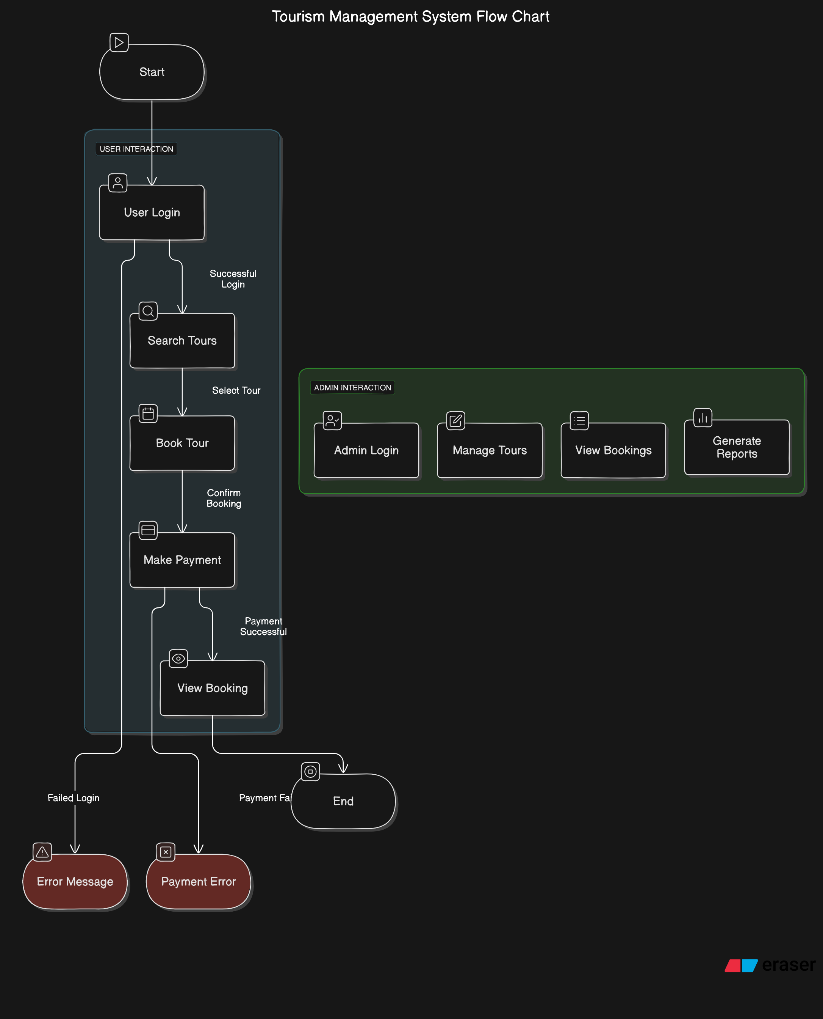

**8.2 : UML Diagrams OR Data Flow Diagram**

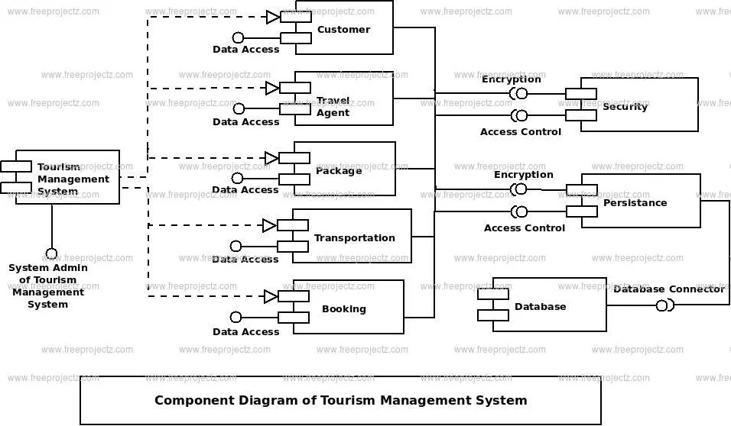

**8.2.1 : USE CASE OR Context Level / 0 level**

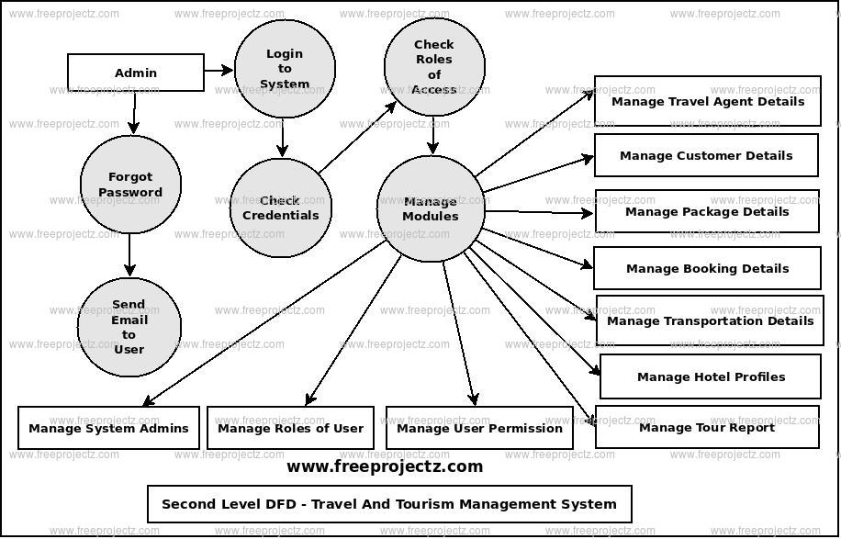

**8.2.2 : ACTIVITY OR First level**

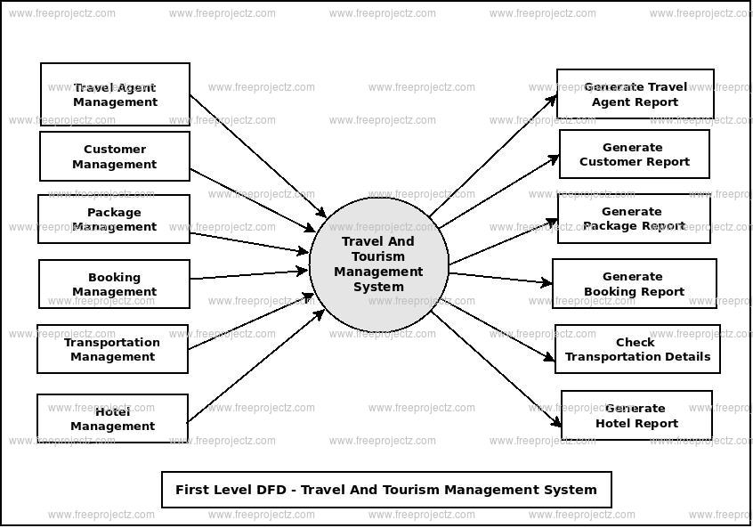

**8.2.3 : SEQUENCE OR Second level**

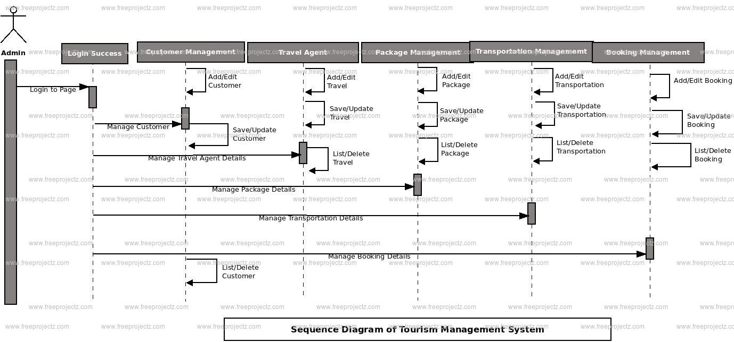

**8.2.4 : CLASS**

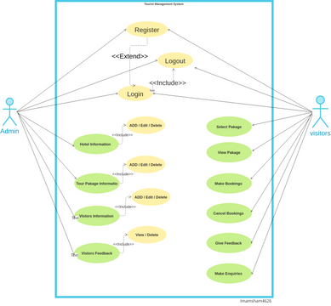

**8.3 : ER Diagram**

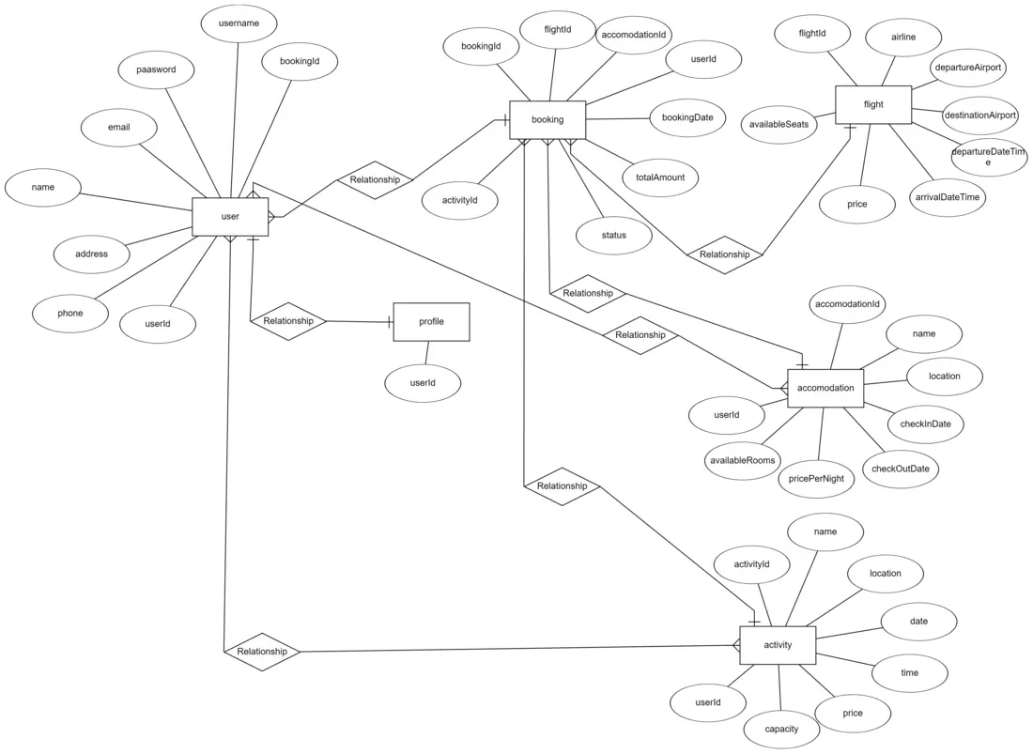

**8.4 : Data Dictionary**

### 1. ****Tourist****

| **Field Name** | **Data Type** | **Description** |
| --- | --- | --- |
| Tourist_ID | INT | Unique identifier for each tourist |
| First_Name | VARCHAR | Tourist's first name |
| Last_Name | VARCHAR | Tourist's last name |
| Email | VARCHAR | Tourist's email address |
| Phone_Number | VARCHAR | Tourist's contact number |
| Nationality | VARCHAR | Tourist's nationality |
| Gender | VARCHAR | Tourist's gender |

### 2. ****Booking****

| **Field Name** | **Data Type** | **Description** |
| --- | --- | --- |
| Booking_ID | INT | Unique identifier for each booking |
| Tourist_ID | INT | Reference to Tourist_ID from Tourist table |
| Destination_ID | INT | Reference to Destination_ID from Destination table |
| Booking_Date | DATE | Date when the booking was made |
| Start_Date | DATE | Start date of the trip |
| End_Date | DATE | End date of the trip |
| Total_Cost | DECIMAL | Total cost of the booking |
| Payment_Status | VARCHAR | Status of payment (Paid, Pending, etc.) |

### 3. ****Destination****

| **Field Name** | **Data Type** | **Description** |
| --- | --- | --- |
| Destination_ID | INT | Unique identifier for each destination |
| Destination_Name | VARCHAR | Name of the destination |
| Location | VARCHAR | Geographical location (city, country, etc.) |
| Description | TEXT | Description of the destination |
| Category | VARCHAR | Type of destination (Beach, Mountain, etc.) |
| Rating | DECIMAL | Average rating of the destination |

### 4. ****Accommodation****

| **Field Name** | **Data Type** | **Description** |
| --- | --- | --- |
| Accommodation_ID | INT | Unique identifier for each accommodation |
| Destination_ID | INT | Reference to Destination_ID from Destination table |
| Name | VARCHAR | Name of the accommodation |
| Type | VARCHAR | Type of accommodation (Hotel, Resort, etc.) |
| Price_Per_Night | DECIMAL | Cost per night of the accommodation |
| Rating | DECIMAL | Rating of the accommodation |

### 5. ****Tourist_Attraction****

| **Field Name** | **Data Type** | **Description** |
| --- | --- | --- |
| Attraction_ID | INT | Unique identifier for each attraction |
| Destination_ID | INT | Reference to Destination_ID from Destination table |
| Attraction_Name | VARCHAR | Name of the tourist attraction |
| Attraction_Type | VARCHAR | Type of attraction (Museum, Park, etc.) |
| Ticket_Price | DECIMAL | Cost of entry to the attraction |
| Opening_Hours | VARCHAR | Opening hours for the attraction |

### 6. ****Payment****

| **Field Name** | **Data Type** | **Description** |
| --- | --- | --- |
| Payment_ID | INT | Unique identifier for each payment |
| Booking_ID | INT | Reference to Booking_ID from Booking table |
| Payment_Method | VARCHAR | Method of payment (Credit Card, PayPal, etc.) |
| Amount_Paid | DECIMAL | Amount paid |
| Payment_Date | DATE | Date of payment |
| Payment_Status | VARCHAR | Status of payment (Completed, Pending, etc.) |

### 7. ****Feedback****

| **Field Name** | **Data Type** | **Description** |
| --- | --- | --- |
| Feedback_ID | INT | Unique identifier for each feedback |
| Tourist_ID | INT | Reference to Tourist_ID from Tourist table |
| Destination_ID | INT | Reference to Destination_ID from Destination table |
| Rating | DECIMAL | Rating provided by the tourist (1-5) |
| Comment | TEXT | Feedback or review given by the tourist |
| Feedback_Date | DATE | Date when the feedback was provided |

**8.5 : SCREENSHOTS OF MODULE**

**Homepage**

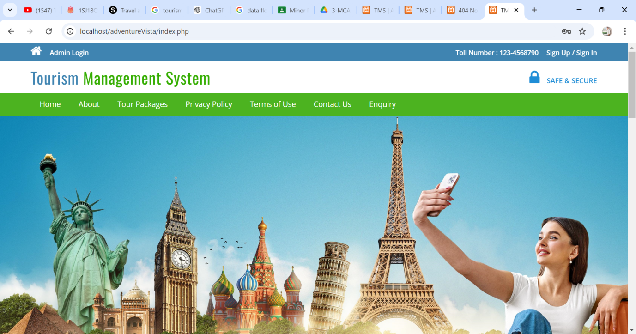

**Package**

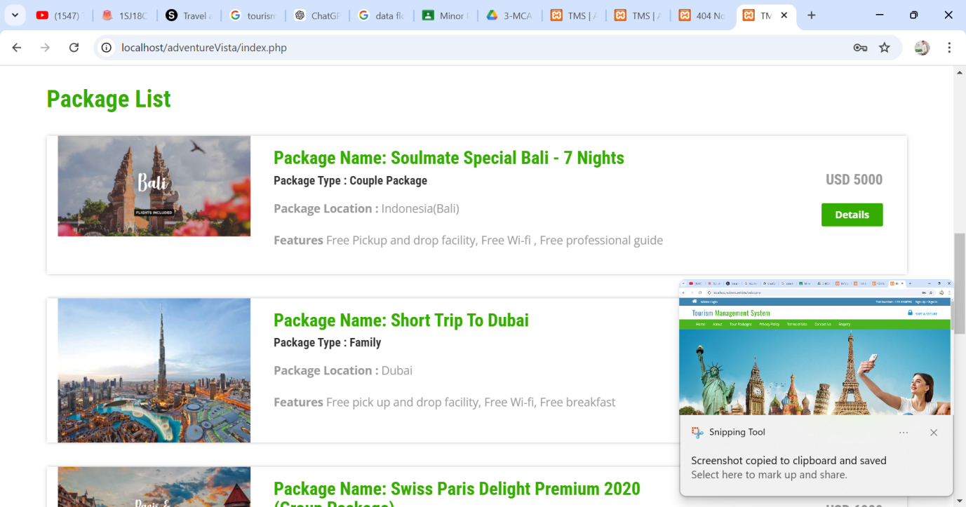

**Package Details**

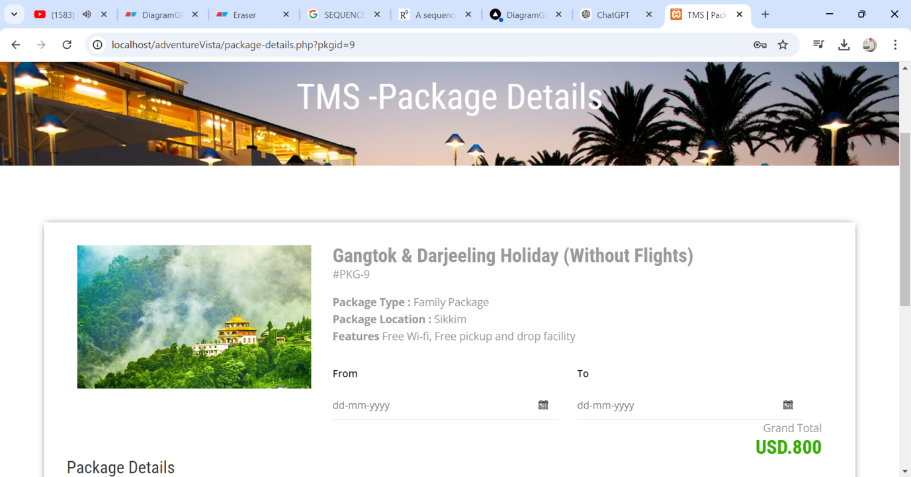

**Log In**

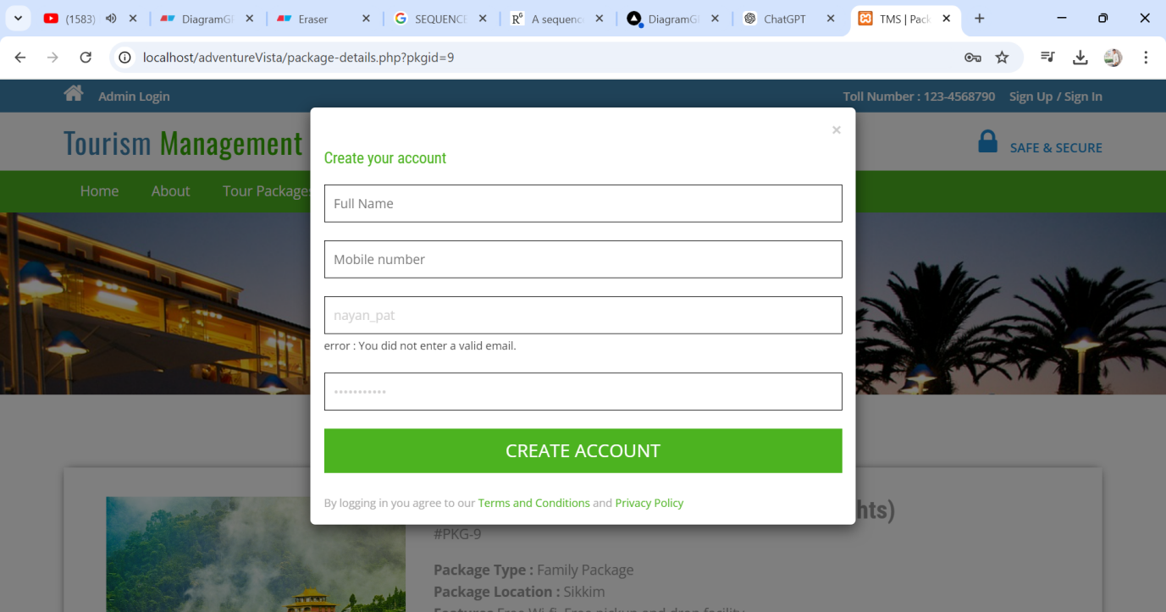

**Sign In**

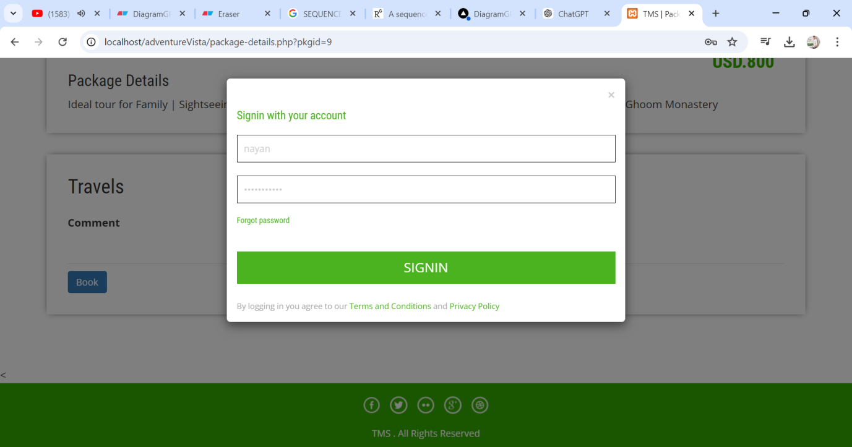

**Admin Login**

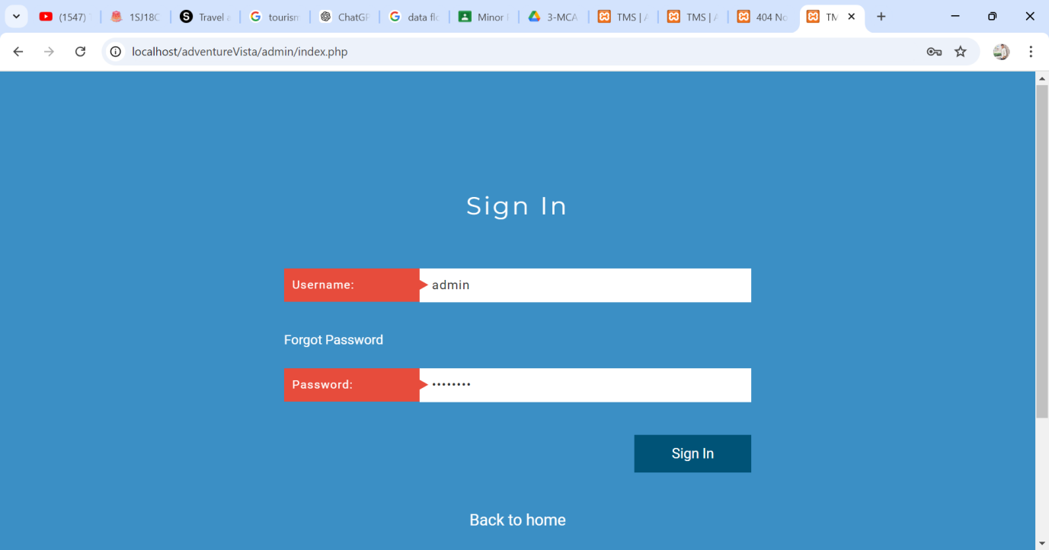

**Enquiry Form Password**

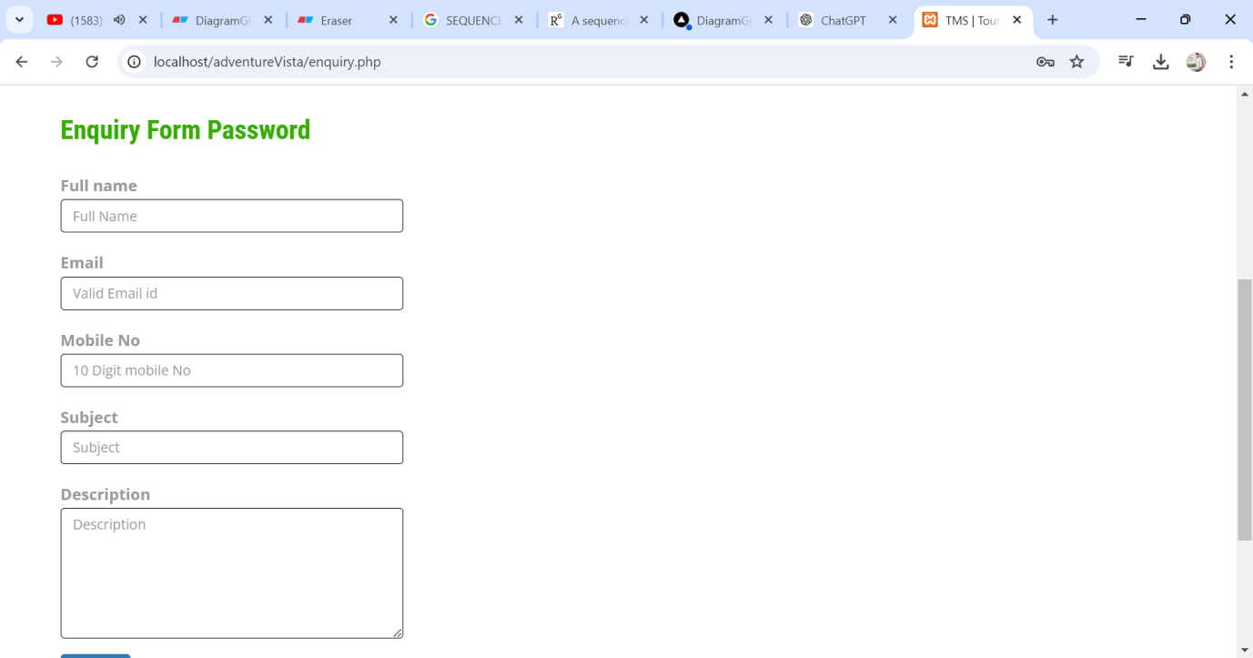

**XAMPP**

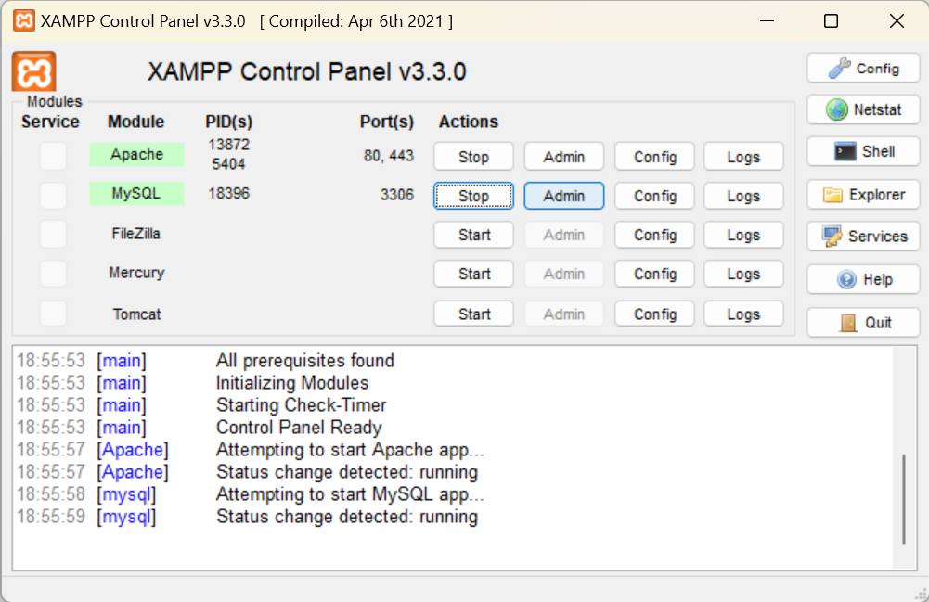

**Dashboard**

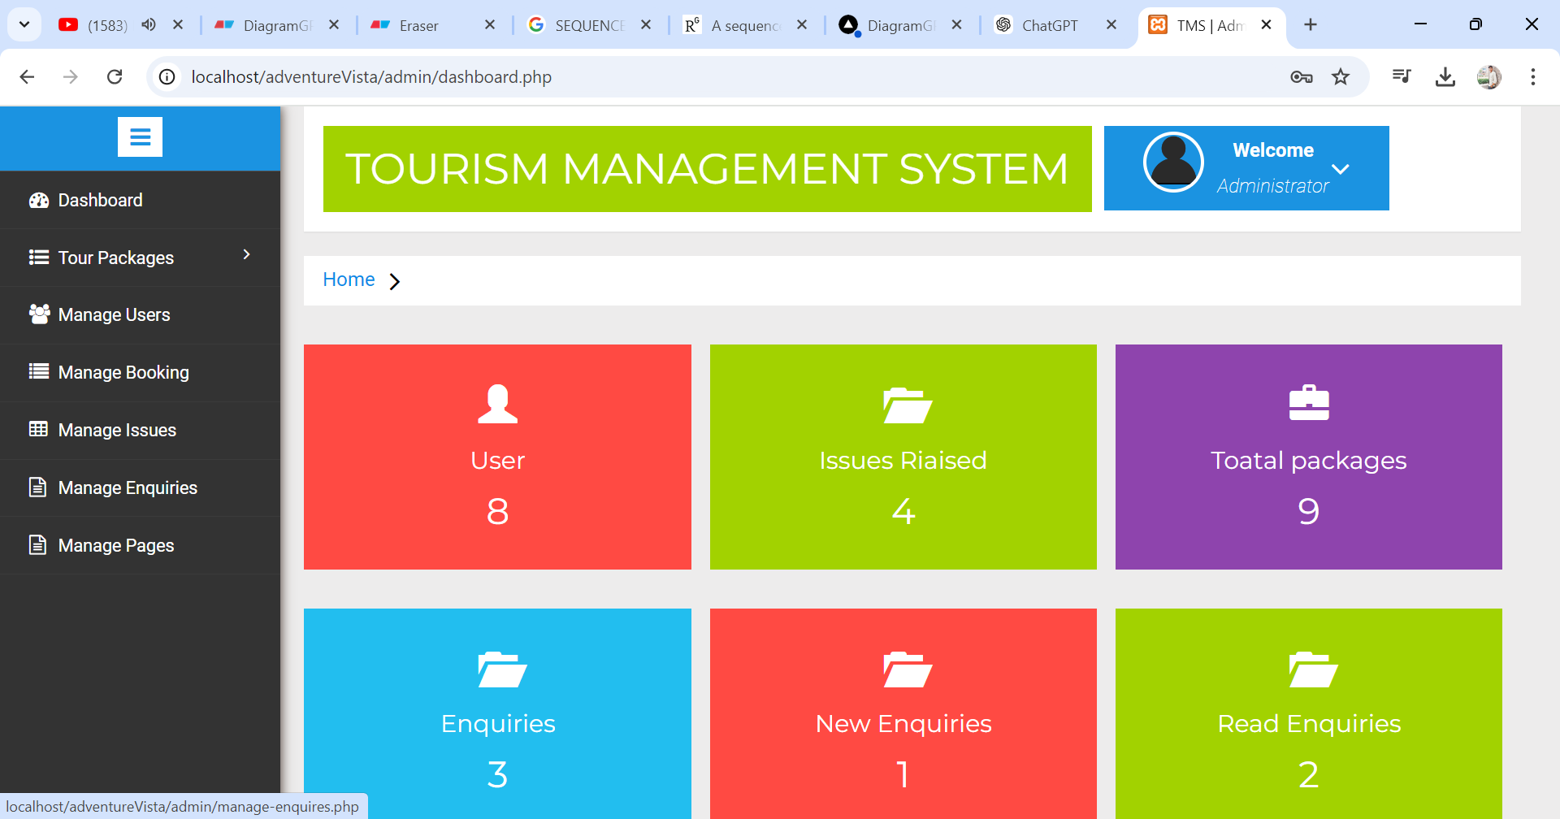

**Manage Users**

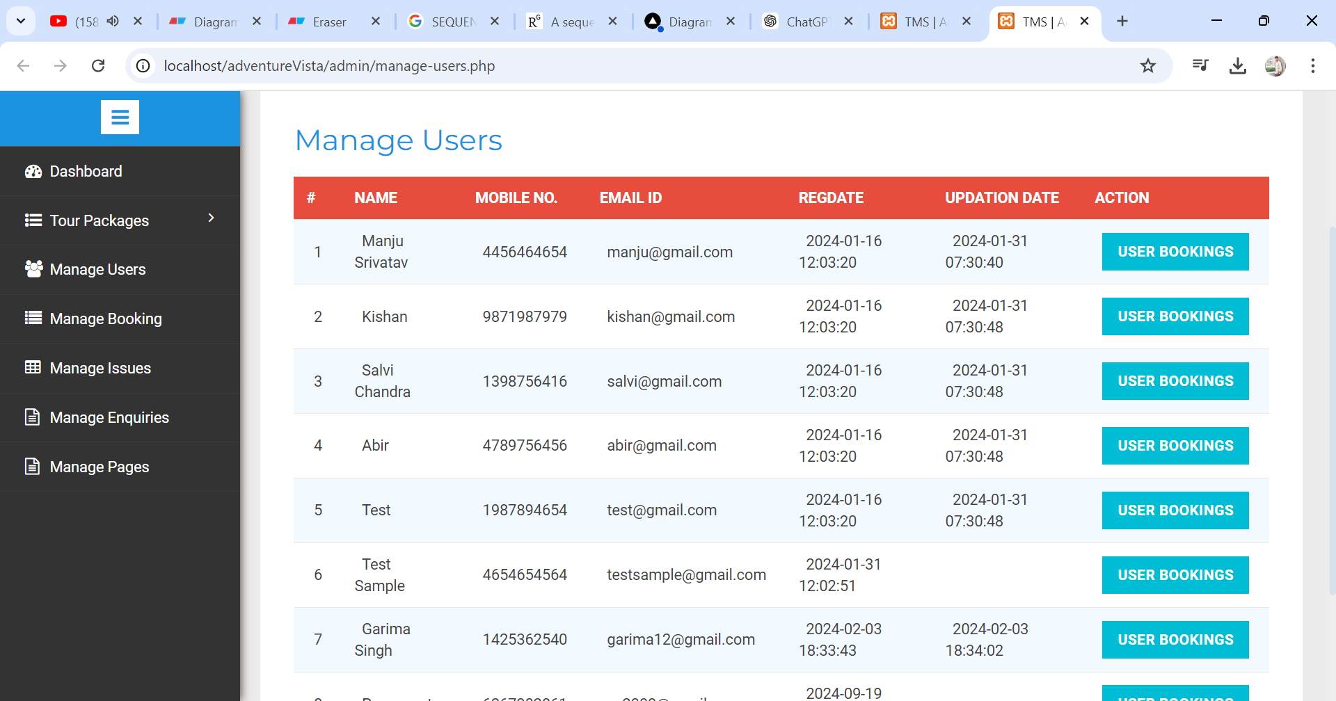

**Manage Packages**

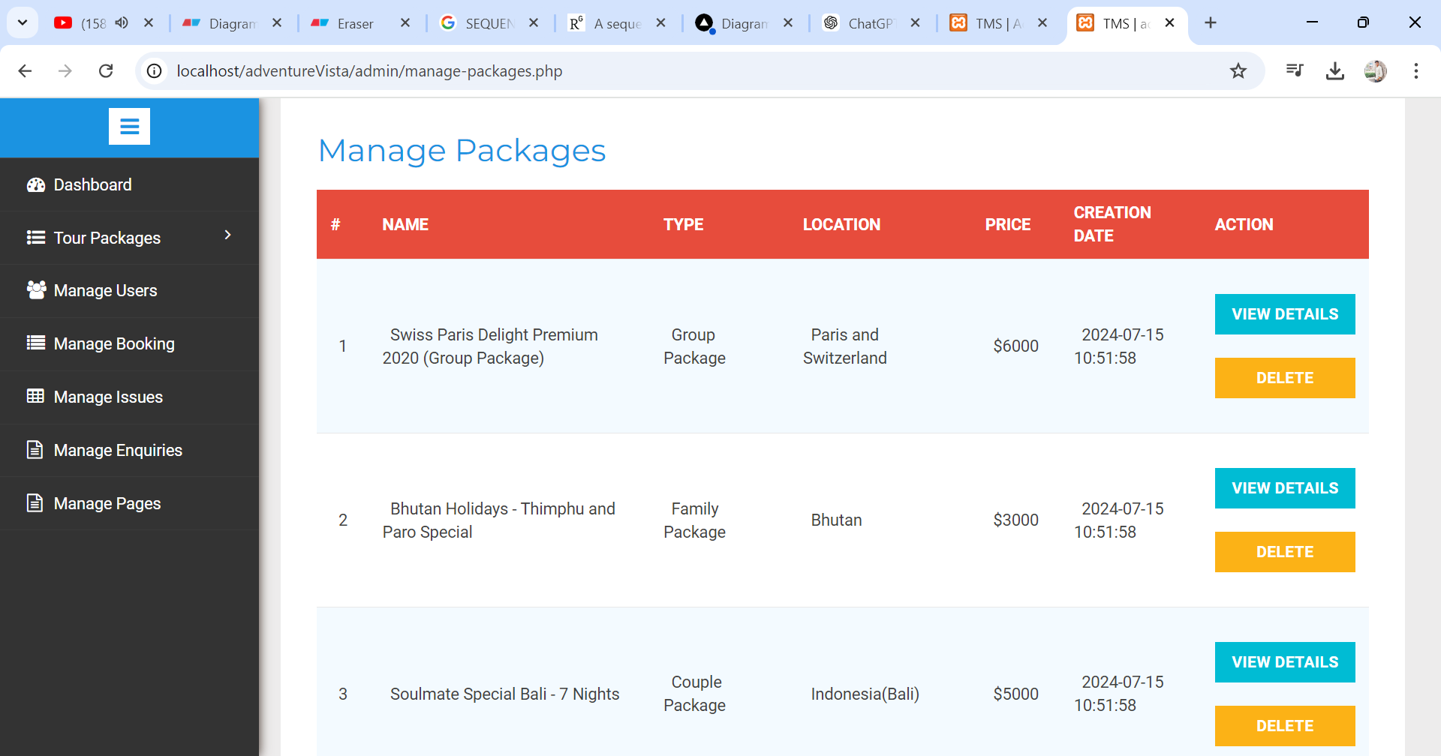

**Create Package**

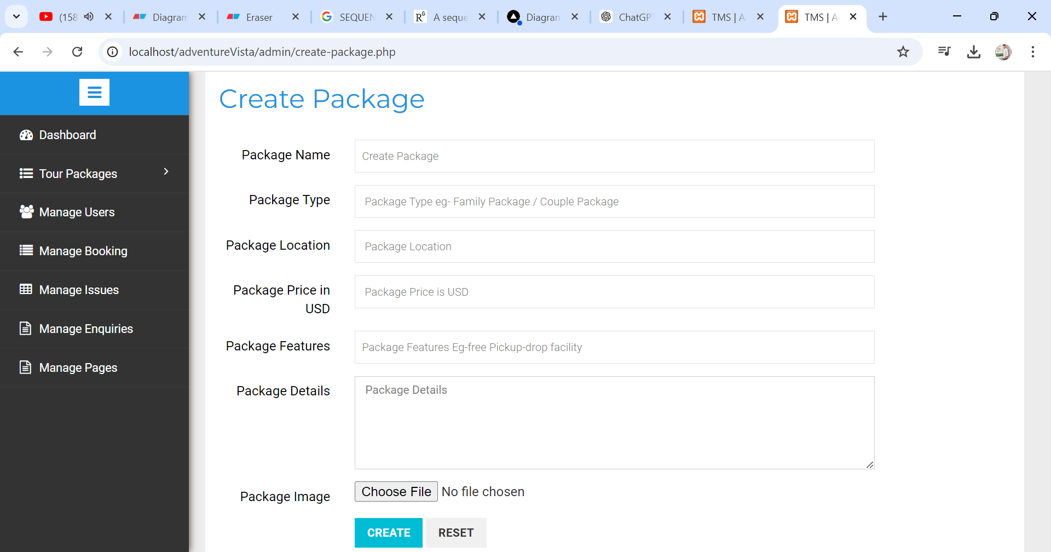

**9.Applications**

**Travel itinerary generator:** A feature that allows users to create a travel plan by adding destinations, tourist attractions, or custom landmarks.

**GIS:** A geographic information system that can be used for digital mapping, 3D models, and virtual tours.

**Easy booking:** A feature that allows travelers to book for themselves, or for employees to book travel for them.

**Enterprise resource planning (ERP):** An application used in tourism and hospitality.

**Customer relationship management (CRM):** An application used in tourism and hospitality.

**10.EXPECTED OUTCOMES**

**Professional skills:** Students learn to use technology to plan and manage tourism experiences.

**Ethics and values:** Students learn to demonstrate ethical practices and respect for diversity.

**Practical skills:** Students learn practical skills in the tourism industry.

**Hospitality culture:** Students learn to develop hospitality culture and behavior.

**Entrepreneurial skills:** Students learn to develop entrepreneurial skills.

**Booking confirmation:** The system verifies bookings made by the admin with the user's date and comment.

**Booking management:** The admin can manage bookings by canceling them

**11.FUTURE SCOPE**

**Digital technologies**

The travel industry is integrating new technologies, such as artificial intelligence, mobile devices, and virtual and metaverse experiences. These technologies can help improve customer experience and efficiency.

**Automation**

Process automation and digitization can help the industry cope with labor shortages and improve efficiency.

**Personalization**

Customers are expecting more personalized experiences, which the industry is trying to meet with new technologies.

**Sustainability**

The industry may see more focus on sustainable development fees and wellness-focused travel.

**Tourism management systems**

These systems can help with trip booking, management, and reporting. They can also automate corporate travel policies and consolidate travel invoices and vendors.

**12. REFERENCES**

**Google, ChatGPT**